Peyton Bailey
D598 – Task 3

- Explain how the code works for the program you submitted in Task 2.

The programming language that I used for this program is Python. I will provide screenshots of each step of the code, followed by an explanation.

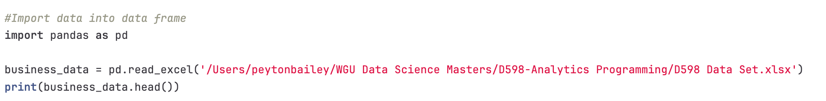
The first step was to import the business data stored locally in an Excel document. This created a data frame called “business_data.”

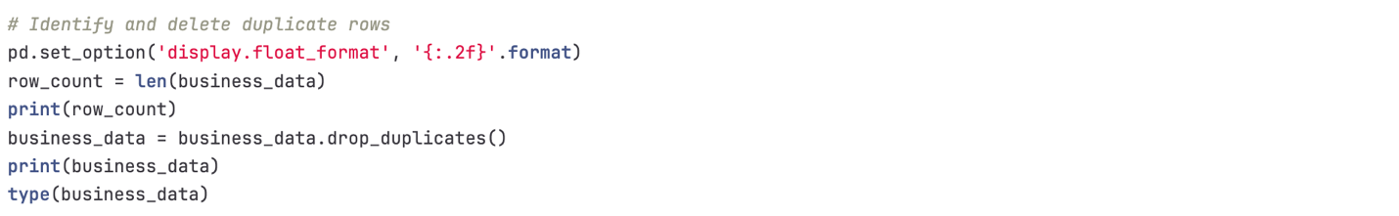

Next, I used the drop duplicate function to ensure no duplicate rows existed in the data frame.
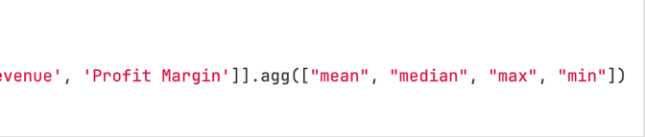
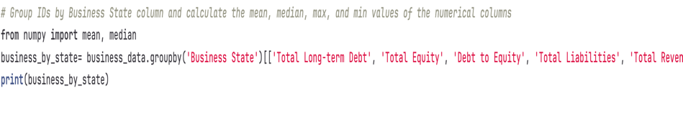
The data was then grouped by state, and descriptive statistics (mean, median, max, min) were performed on the Total Long-Term Debt, Total Equity, Debt to Equity, Total Liabilities, Total Revenue, and Profit Margin columns. This was stored as a new data frame called “business_by_state.”

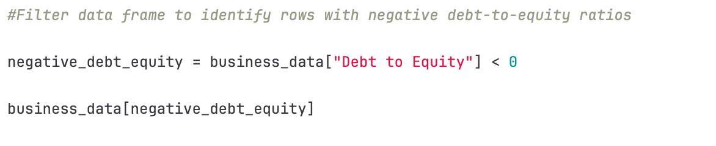

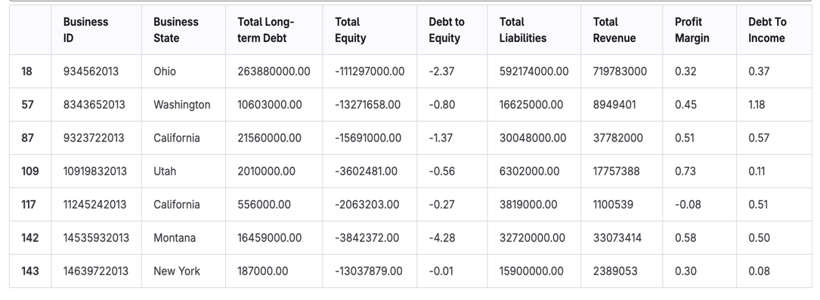

The data was then filtered to identify any businesses with negative debt-to-equity ratios. Seven businesses met this requirement.

The debt-to-income data frame was created by dividing the “Total Long Term Debt” column by the “Total Revenue” column.


The debt-to-income data frame was then joined with the original data frame. The screenshot below shows the debt-to-income added as an additional column.

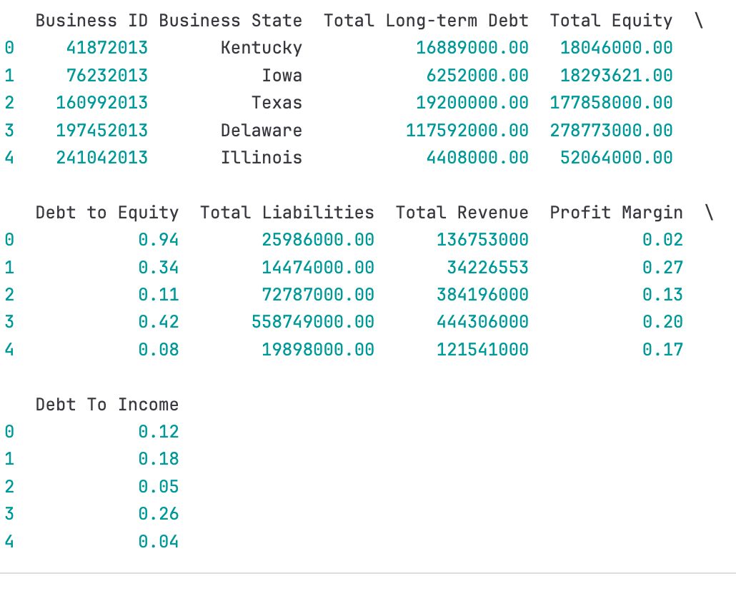

- Provide 4 customized data visualizations.

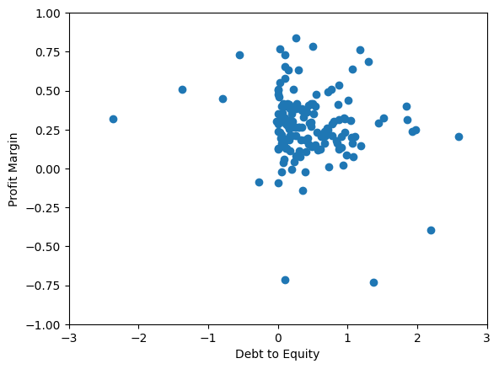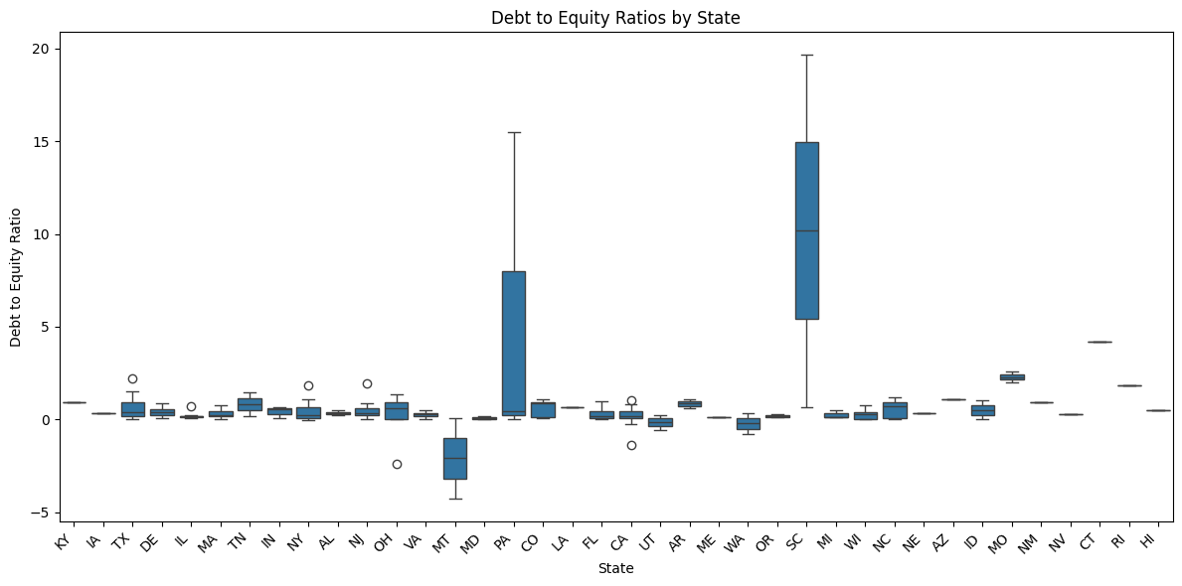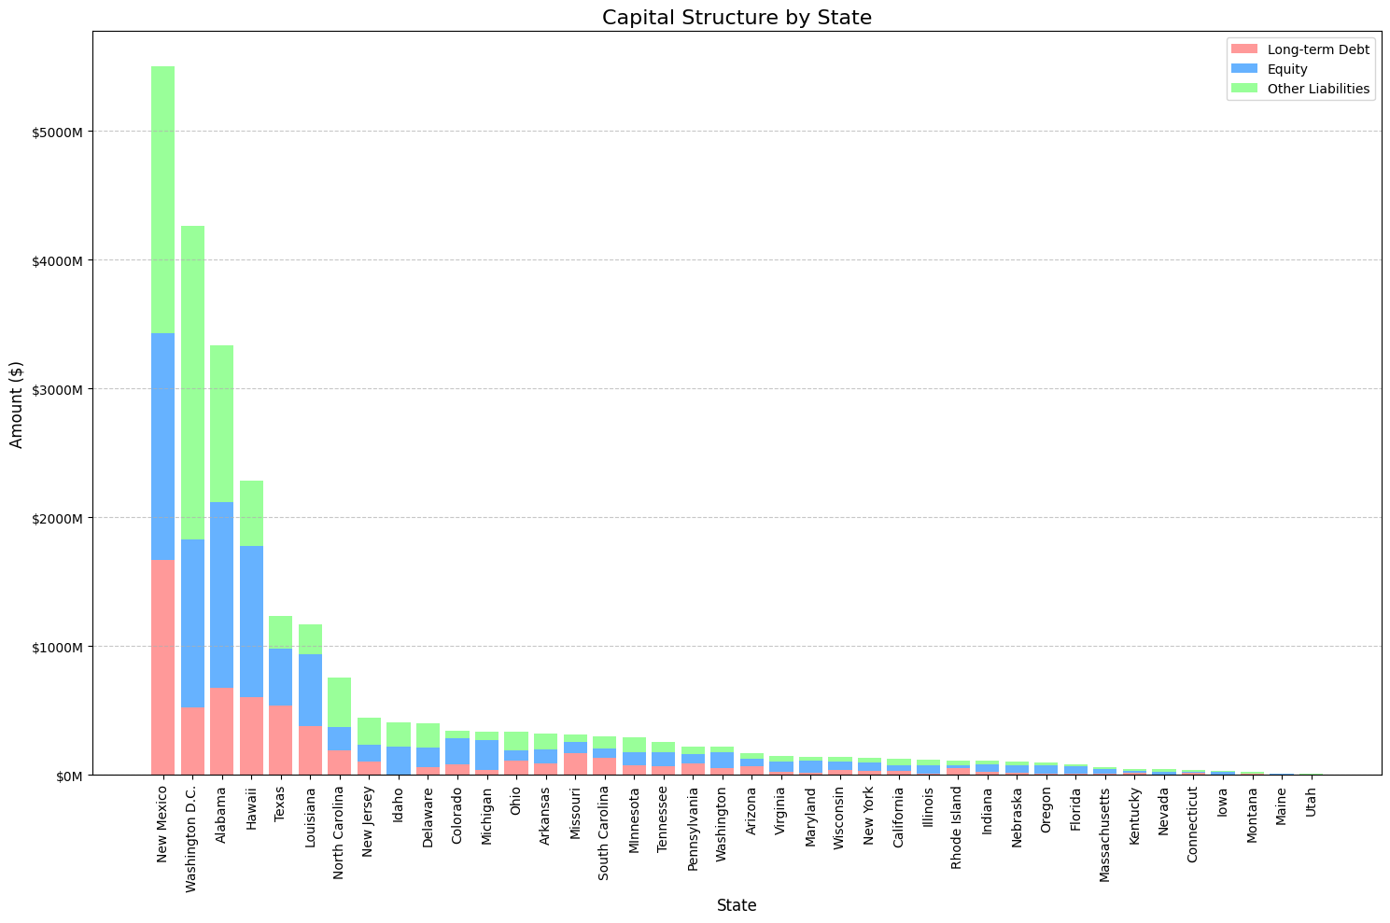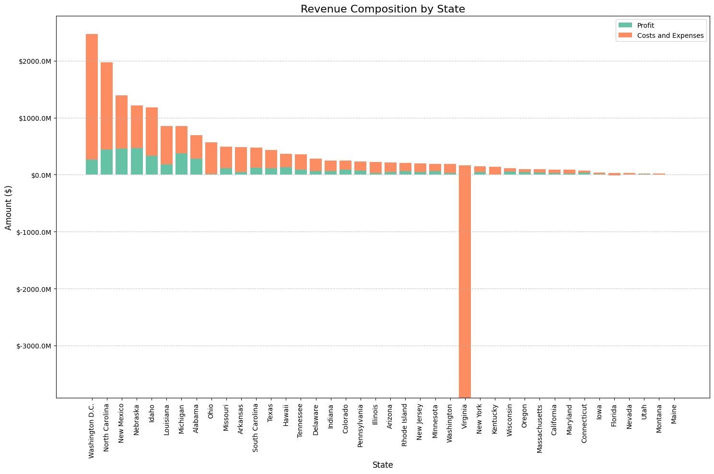

- Explain how customized visualizations in part B were created.

The first visualization is a scatter plot that shows the relationship between the debt-to-equity ratio and average profit margin for each business. The code for creating this graph is below:

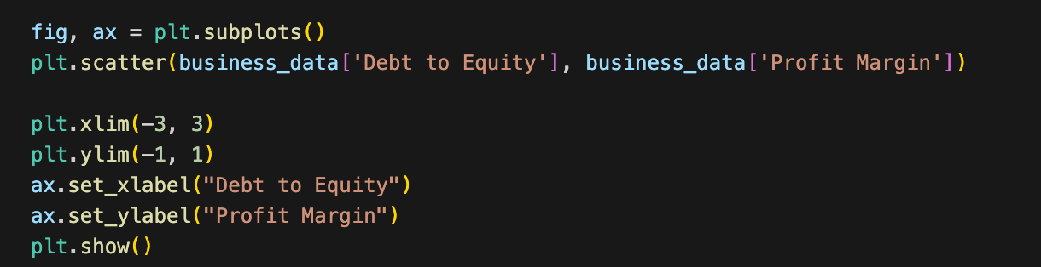

The “Debt to Equity” and “Profit Margin” columns are read as the x and y values and adequately labeled.

Secondly, the following visualization consists of side-by-side box plots. Each box plot depicts debt-to-equity ratios by state. Within each box plot, you can see the min, median, and max ratio and the overall distribution of these ratios within each state. The code used is below:

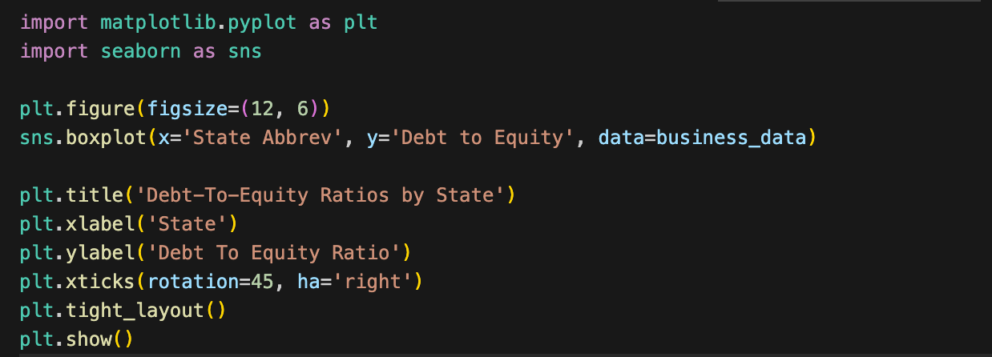

Additionally, I created a dictionary for state abbreviations to make these plots more manageable to read.

The third visualization is a stacked bar chart. This chart is also grouped by state, showing each state’s average long-term debt, equity, and other liabilities as multiple parts to a complete bar. The other liabilities metric was calculated by subtracting the long-term debt from total liabilities. The total bar, the sum of those three metrics, is the total capital or average total by state. The code is shown below:

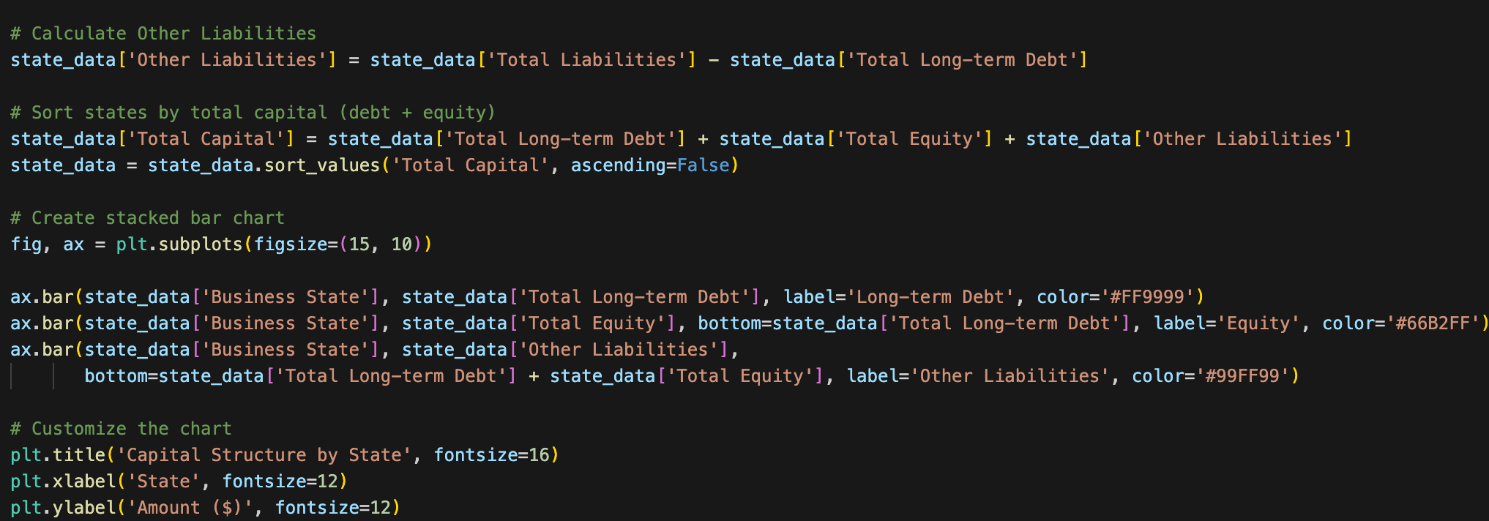
Finally, the last visualization is another stacked bar chart titled “Revenue Composition by State.” This was done by grouping the data by state and calculating the average total revenue and profit margin. Afterward, profit and cost had to be calculated. Profit was calculated by multiplying the total revenue by the profit margin. The price was calculated by subtracting the profit from the total revenue. The following steps were very similar to those from the previous visualization. Interestingly, this chart allowed me to see a significant anomaly from the state of Virginia, which was the only highly negative bar. Upon further research, one of the businesses within that state had an abnormally high negative profit margin, which significantly impacted the state’s overall averages.

